
Khwaja Yunus Ali University

Lab Report -08

Name of the Department: Computer Science and Engineering
Course Code: CSE 0713-1104
Course Title: Electrical Circuit Lab
Experiment No.: 08
Name of the Experiment : Study of Resonance behavior of a series of RLC circuits with variable Capacitance.
Date of Experiment : 06-04-2025
Date of Submission : 13-04-2025

Instructor Signature & Date

Submitted by – |  | Submitted to –

Name: Md Sojib Ahmed
ID Number: 06224205101006
Batch No: 18th
Semester: 1st Year 2nd Semester
Khwaja Yunus Ali University

Name: Sakil Ahammed
Lecturer
Department of EEE
Khwaja Yunus Ali University

Name of the Experiment:
Measurement of Power and Power Factor using AC Circuit

Objectives:
- To measure power and power factor in a series RLC circuit using simulation.
- To understand the phase relationship between voltage and current.

Theory:
In AC circuits, power can be classified into three types:
- Real Power (P): The actual power consumed (in Watts).
- Apparent Power (S): The product of RMS voltage and current (in Volt-Amperes).
- Power Factor (pf): The ratio of real power to apparent power, given by:

$$\text{ Power Factor }=cos⁡θ=\frac{P}{S}$$
For sinusoidal signals:
$$V_{rms}=\frac{V_{m}}{\sqrt{2}}, I_{rms}=\frac{I_{m}}{\sqrt{2}}$$
Power factor indicates whether the circuit is resistive, inductive, or capacitive in nature.

Circuit Diagram:

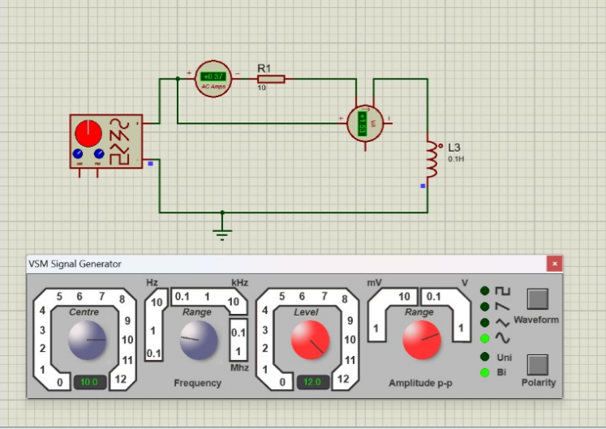

Fig. (1) AC Circuit for Power and Power Factor Measurement

Apparatus Used:
- AC Signal Generator
- Ammeter
- Voltmeter
- Resistor (R = 10Ω)
- Inductor (L = 0.1H)
- Proteus 8 Professional Software
- Connecting Wires

Working Procedure:
- Opened Proteus 8 and constructed the circuit as shown.
- Connected the ammeter in series and voltmeter in parallel with the load.
- Used a VSM Signal Generator to supply AC voltage.
- Measured the RMS current and peak voltage.
- Calculated the real and apparent power.
- Computed the power factor using the given formula.

Given Data:
- Peak Voltage, $V_{m}=52 V$
- Current, $I=0.37$ A
- Real Power, $P=3.53 W$

Calculation:
Apparent Power (S):
$$\begin{matrix}V_{rms}=\frac{V_{m}}{\sqrt{2}}=\frac{52}{1.414}=36.77 V \\ S=V_{rms}×I=36.77×0.37=13.6VA\end{matrix}$$
Power Factor (pf):
$$cos⁡θ=\frac{P}{S}=\frac{3.53}{13.6}≈0.26$$

SL No. | Peak Voltage (V) | RMS Voltage (V) | Current (A) | Apparent Power (VA) | Real Power (W) | Power Factor
1 | 52 | 36.77 | 0.37 | 13.60 | 3.53 | 0.26
2 | 48 | 33.94 | 0.35 | 11.88 | 3.10 | 0.26
3 | 44 | 31.11 | 0.33 | 10.27 | 2.80 | 0.27
4 | 40 | 28.28 | 0.30 | 8.48 | 2.30 | 0.27

Result and Discussion:
- The apparent power was calculated to be 13.6 VA, and the real power measured was 3.53 W.
- This resulted in a power factor of 0.26, indicating a predominantly inductive circuit.
- The simulation verified the effect of phase difference between voltage and current on power factor.
- A low power factor suggests inefficiency due to reactive components.

Conclusion:
In this experiment, we successfully measured real and apparent power and determined the power factor of a series RLC circuit. The observed low power factor demonstrates the influence of inductive reactance, validating the concept of reactive power in AC circuits.

